Postdoctoral Fellowship in
Clinical Health Psychology
Online applications begin October 1
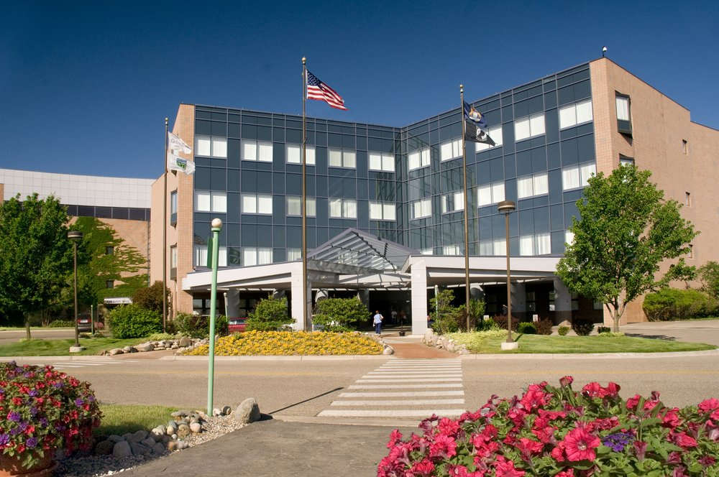

One Genesys Parkway
Grand Blanc, MI 48439

phone 810.606.5980 fax 810.606.5636
ascension.org

Welcome

Thank you for your interest in our Clinical Health Psychology Postdoctoral Fellowship. On behalf of myself, and our attending faculty, Scott Nyman, Ph.D., ABPP, Por Por Phunwutikorn, Ph.D., and Rebecca Sewell, Ph.D., I would like to thank you for considering our program for your fellowship capstone training experience. The Genesys program is a streamlined 1-year model, which aligns with the state of Michigan licensure laws, which require only a 1-year (2,000-hour) postdoctoral training experience and is consistent with APA postdoctoral training standards.

As you may have already reviewed on our website, our fellowship program offers three distinct, 4-month training rotations: Hospital based consultation-liaison service, Family Medicine outpatient clinic, and Internal Medicine / OB outpatient clinic. We strive to offer a fellowship model that provides advanced training in Medical Education and integrated primary care (IPC) across three unique training settings, such that our graduates are well prepared to enter clinical leadership positions within traditional medical settings upon graduation. Our web page (http://bit.ly/GenesysCHP) offers further detail regarding our training program and curriculum specifics.

Should you have any questions regarding our fellowship program please do not hesitate to contact any of our program faculty:
• Dr. Heather Kirkpatrick: Heather.Kirkpatrick@ascension.org
• Dr. Scott Nyman: Scott.Nyman@ascension.org
- Dr. Por Por Phunwutikorn: porpor.phunwutikorn@ascension.org
• Dr. Rebecca Sewell: Rebecca.Sewell@ascension.org

Our fellowship is consistently rated highly by our graduates as providing a high-quality experience with specialized training and excellent supervision. We hope you will consider joining our team.

Thank you,

Heather Kirkpatrick, Ph.D., ABPP

Application Process

Applications can be completed using the APPA CAS system. Alternatively, applicants can email Alice Barillas (alice.barillas@ascension.org) the following documents: Cover Letter, Personal Statement of Interest, Curriculum Vitae, Three (3) Letters of Recommendation (One must be from your current supervisor - may be mailed or emailed and must come directly from the letter writer), and Official Transcripts (May be mailed or emailed but must come directly from the institution). Deadline for applications are posted on our website and APPA CAS.

Program synopsis
The Ascension Genesys Fellowship in Clinical Health Psychology (CHP) provides advanced training in the recognized specialty practice area of clinical health psychology that interfaces with medicine, using guidelines recommended by experts in the field, accreditation standards set by the American Psychological Association (APA), education and training guidelines of the specialty, the needs of supporting institutions, and the needs and interests of trainees. Training is provided in an atmosphere of individual and cultural diversity, cultural awareness, and equal opportunity.
The Ascension Genesys clinical health psychology Fellowship provides a twelve-month (1 year), full-time, advanced training program for doctoral-level psychologists. This comprehensive training program prepares graduates for independent practice as Clinical Health Psychologists. Graduating Fellows will be capable of assuming advanced / leadership roles in healthcare settings (e.g., primary care and specialty care) and, during Fellowship, will receive didactics / exposure to developing programs, service lines, and transdisciplinary teams within health care settings. Graduates will also be able to assume leadership roles in teaching and medical education settings, make meaningful scholarly contributions within healthcare settings, and being active in relevant professional organizations.

The Fellowship operates on a clinical-educator model designed to teach collaborative and integrated care within medical / healthcare settings. The aims of the program are consistent with the mission of Ascension Genesys Hospital
Aims of the Program
Aim 1: Clinical Expertise. Develop advanced practice clinical competency in Clinical Health Psychology with sufficient preparation to be credentialed and ultimately Board certified by ABPP Aim 2: Teaching-Supervision. Develop the ability to provide effective teaching with a broad range of health care providers.
Aim 3: Team Approach. Develop expertise in hospital and ambulatory practice involving a transdisciplinary model within a team process approach.
Aim 4: Scholarly Activity. Develop the ability to critically review research, adopting a commitment to lifelong learning while making make scholarly contributions to the field.

Expected Fellow Competencies
The program trains graduates of the program to meet both Profession Wide Competencies and the Specialty Specific Competencies for Clinical Health Psychology as established by the specialty. A Complete list of these competencies can be found on the www.cospp.org site here

Our Model of Training

At Genesys, our Clinical Health Psychology program is embedded in our medical primary care residency programs (Family Medicine and Internal Medicine, OB/GYN). Since 1987, the core of our fellowship program has been to train psychology fellows alongside their medical colleagues. The psychology fellows are able to lend their expertise to and teach the medical resident in the learning of behavioral issues related to disease and health. Likewise, the medical resident has a role in teaching the psychology fellow more about medical diagnoses and treatment so that the psychologist can be a more effective colleague.

We focus on Primary Care applications of clinical health psychology. This area has broad implication for psychologists in medical settings as primary-care physicians identify a large portion of their patients as needing some mental health treatment, but fewer than 10 percent of these patients actually see a mental health professional. In order to meet this demand, we have focused on training primary-care psychologists to offer counseling and behavioral interventions to patients in medical settings. Our arrangement is collaborative and integrated. Our assessment and interventions work to help patients—often on the same day and sometimes without the patients ever leaving the exam room— and to train primary care physicians as to how to work collaboratively.

Our clinical training operates from an Integrated Primary Care (IPC) Model where clinical assessments and interventions are provided with primary care medicine to more fully address the spectrum of problems that patients bring to a primary medical site. This model functions with the psychologists as behavioral health providers (BHP) in the primary care clinic area receiving immediate "hallway handoffs", triaging cases, providing brief (15-20 minutes) behavioral interventions as well as short-term (3-6 sessions) solution-focused and evidence based interventions, and offering quick feedback to providers. The CHP fellows collaborate with the medical team to provide ongoing assessment, flexible treatment services, and regular monitoring of patient progress. Interventions target behavioral issues that affect a specific physical health problem (e.g., motivational interviewing for a patient with medication non-adherence; behavioral activation for patient with diabetes displaying symptoms of depression). These brief and focused interventions serve to complement the complete medical care of the patient, while reducing the burden on the primary care medical team.

Clinical Rotations
There are three rotations during the fellowship. Each is approximately four months in duration. Fellows rotate through each rotation during the fellowship year with one fellow assigned to one rotation, and all fellows complete all three rotations.
- Family Medicine
- Internal Medicine/OB
- Hospital Consultation-Liaison

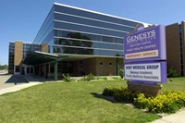
Family Medicine: East Flint Campus Rotation
The East Flint Campus Rotation offers fellows the opportunity to function as a clinical health psychologist within a family medicine residency training clinic. One of the central components of the fellowship program is medical education. Fellows are involved in designing and implementing the behavioral science curriculum for the family medicine residency program and shadowing residents during medical appointments to promote improved doctor-patient communication skills, time efficiency, and overall high quality whole-person patient care. Fellows also gain clinical health psychology skills and assist residents in learning psychosocial aspects of family medicine via our Integrated Primary Care (IPC) service delivery model, ADHD assessment clinic, and Lifestyle Change Clinic.
- Integrated Primary Care (IPC) is our main approach to reaching our patients' immediate physical and mental health needs while concurrently providing medical education for family medicine physicians, who learn alongside the psychology fellow. The psychology fellow addresses a variety of presenting problems common to the primary care medical setting including traditional mental health concerns (e.g., generalized anxiety, panic disorder, and major depression), as well as more specialized clinical health psychology concerns including medication adherence, emotional adjustment to new medical diagnosis / physical pain / physical injury etc., and coping with chronic medical conditions. The fellow position is primarily IPC in nature, operating out of the medical preceptor's office and resident physician work stations. The fellow also maintains 5 hours per week for scheduled psychotherapy appointments, which are short-term in nature. We typically only provide psychotherapy services for mild-moderate severity levels, while referring more severe cases out to our local community psychiatric / mental health centers. Resident physicians may observe some of these IPC evaluations and treatment sessions during their Behavioral Science residency rotation. This training opportunity aims to prepare health psychologists to function effectively in an outpatient medical setting as well as in medical residency training settings.
- ADHD Assessment Clinic: This is a clinic for children and adolescents referred from our resident physicians for an ADHD screening evaluation. The fellow and family medicine physician work collaboratively in this clinic with the physician performing a physical exam and the fellow conducting the clinical interview, interpreting screener results, and providing feedback and recommendations to the patient and parents.
- Lifestyle Change Clinic: This is a weekly clinic operated by the psychology fellow and 1-2 family medicine residents, and aims to assist patients identified by their primary care physician as needing assistance with weight management, smoking cessation, or increased physical activity. The fellow assists the resident physician in learning motivational interviewing strategies for healthy behavior change while concurrently providing clinical services to patients.

Internal Medicine & OB/GYN - Downtown Flint Campus
The psychology fellow at the Genesys Downtown Flint Health Center is an integrated member of the internal medicine and obstetrics-gynecology treatment teams. This setting is a busy academic ambulatory practice in which approximately 10,000 patient visits occur each year. These visits occur in the internal medicine residency program, the obstetric-gynecology residency program, the podiatry residency program, the general surgery program, the gastrointestinal fellowship program, and the behavioral science psychology program.
The main focus of this rotation is to continue to refine medical education skills in a setting requiring a higher level of autonomy, while also providing clinical consultation to the primary care ambulatory practices. Fellows participate in the following teaching activities:
- Shadowing internal medicine and OB-GYN residents to provide feedback about both clinical content related to psychology, but also strategies to improve doctor-patient relationships, advanced counseling skills, and time efficiency.
- Videorecording internal medicine and OB-GYN residents co-jointly with physician faculty to improve residents’ skills
- Designing curriculum to improve the patient experience and physician skills and confidence
- Precepting clinical cases with physicians
Clinically, the psychology fellow provides a variety of services to our patient population. Fellows typically carry a caseload of approximately 20-25 patients, with approximately 10 clinical contact hours per week. Many of these encounters are traditional psychotherapy cases, but approximately 25-50% of them are triage primary care appointments. These triage services use an integrated primary care psychology approach. Fellows typically treat patients collaboratively with their physician health care provider. Presenting concerns mirror a primary care practice. They can include:

- adjustment to medical illness
- health related behavior
- Gut directed hypnotherapy
- neuropsychological screening
- chronic pain
- uncomplicated depression
- panic disorder assessment and treatment
- substance abuse
- trauma

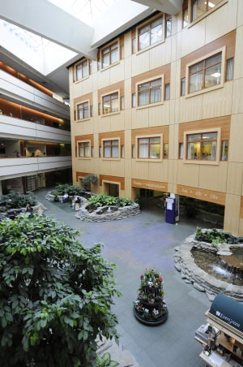
Hospital C-L Rotation
The psychology consult service responds to requests for consults, assessing mental health problems among admitted patients on the general floor and providing treatment recommendations to the medical team regarding patient needs.
Commonly encountered referral questions include:
- assessment and treatment of anxiety and depression
- pain assessment and management
- capacity for medical decision-making
We also provide follow-up services to patients as needed, such as relaxation training, pain management, and behavioral activation.
We work closely with the family practice and internal medicine teams, including residents and attendings, regarding patient care.
Other responsibilities include completing pre-surgical psychological evaluations for bariatric surgery center at Genesys and providing behavioral medicine lectures within the hospital to various groups of residents and medical students. The psychology fellow works closely with a psychology faculty member, who provides supervision and didactic training covering topics pertinent to psychologists working in inpatient settings.

Populations Served
As typical of primary care and hospital-based services, fellows work with patients across the age spectrum ranging from childhood to geriatrics. Most patients seen by fellows in the hospital setting are adult or geriatric, while in primary care there is greater opportunity to work with children and adolescents. From an SES standpoint, the EFC and DFHC settings serve a primarily medically underserved, lower SES patient population, while the hospital-based service includes a higher SES population with higher rates of private and Medicare insurance coverage. Both the EFC and DFHC settings are located within urban environments in the Greater Flint Community, and have patient populations comprised ethnically/racially of White (72.5%), Black (20.2%), Hispanic (3.1%), Mixed (2.7%), Asian (1%), and other (0.5%). Fellows routinely work with first generation immigrants, patients with disabilities, and LGBTQ individuals.

Benefits of the Program to Fellows

Individual Supervision. Individual face-to-face supervision occurs, at a minimum, of two (2) hours per week. Fellows receive supervision from three different primary supervisors during the training year, with their 4-month rotation-based Core Faculty serving as their primary supervisor. The content of supervision is consistent with the Fellows training activities and the methods are matched to the experience and training level of the Fellow. There is daily contact between supervisors and Fellows. Additional consultation is available as needed.

Medical Education Training: Fellows receive training in medical education techniques and procedures. They then apply this knowledge by working with medical students, medical residents, and attending physicians. The information taught is primarily focused on the application of the biopsychosocial model.

Didactics : The program offers extensive didactic experiences and opportunities. We partner with local postdoctoral fellowship programs to provide a wide complement of Structured Didactic Training Activities. These include:
• Clinical Health Psychology Core Seminars
• Functioning as a Psychologist in a Medical Setting
• Psychology in Primary Care & Health Related Behavior Change
• Professionalism & Diversity
• Coping with Chronic and Terminal Illness
• Assessment
• Psychopharmacology curriculum
• Pathophysiology (by attending Ascension Genesys Congdon Lecture series)
• Rehabilitation Psychology Seminars
• Leadership and Management Seminars
• Diversity training and activities
• Personal wellness training and activities
• Guest speakers

Case Consultation Seminar. Ascension Genesys faculty and fellows meet monthly for case-based conferences in which both fellow and faculty present and discuss interesting and unique cases. Fellows will have a regular responsibility to present cases from their clinical rotations/experiences. The focus of this case conference is to develop a better understanding of the clinical health psychologist’s role in medical settings, improve differential diagnosis, and share case material across multiple practice settings.

Accreditation
Ascension Genesys Hospital is accredited in the specialty areas of Clinical Health Psychology by the American Psychological Association (APA) Commission on Accreditation.
What does APA accreditation mean to you? The advantages to you are many. You know that you are applying to a training program that meets APA's high standards for excellence. After you graduate, those who evaluate your credentials for professional entry into restricted clinical practice settings such as hospitals, medical centers, and provider panels, as well as licensure boards, professional societies, courts, and other situations where expertise is demanded, will also know immediately that your capstone training was of the highest quality.
Program Support
Ascension Genesys provides direct administrative support in overall Fellowship functioning. Ascension Genesys can also arrange for faculty appointments for Fellows and Core Faculty through Michigan State University, College of Human Medicine in relation to their teaching role with medical residents.
Financial Assistance: Fellows’ financial compensation and benefits package is outlined within their Ascension Genesys Medical Education Department contract for employment.
Salary/Stipend: | $53, 974
Personal Development Education Account (PDEA: PDEA funds to be used for relevant education and training expenses. PDEA funds are provided with two installment checks during the training year. | $3,000
Paid Time Off:  (includes vacation, personal, sick and/or conference time) | 20 days
Additional Benefits | • Medical Insurance  • Life insurance policy  • Dental/Optical insurance; coverage available up to full family  • Professional liability insurance  • Lab coat allowance (with monogramming)

Requirements for Completion
To receive a Certificate of Completion at the end of the training, the Fellow must meet Minimal Levels of Achievement (MLA) at the final evaluation period (12 months) and have accrued 2,000 hours of supervised training. The program evaluation forms use the item rating of “meets expectations” to indicate the performance is at an advanced level consistent with peers at a similar level of training. In order to successfully complete the Fellowship program, at the 12-month evaluation period, a Fellow must achieve a rating of “meets competency” on all four Aims of the program. In addition, for profession wide and specialty specific competencies the Fellow must receive a final rating of “competent” or higher on all competencies. The Certificate of Completion attests to the Fellow’s completion of 2,000 hours of supervised training and consistent achievement of all competencies relevant to the goals of the program.
The total time to completion of the program is 12 months of full-time training. The average amount of time per week spent in direct service delivery and other educational, training, and program activities is 45 hours.
Initial Placement of Graduate Fellows
All graduated fellows are licensed to practice psychology in one or more states. Our fellows all have started careers in health psychology in various settings, including private practice, medical centers, academic health centers or the Veterans Administration Health System. Almost half of the graduates have teaching roles within these settings. The program conducts regular reviews so that fellows can provide input for ongoing improvement in the program. Fellows have expressed satisfaction with the training offered and have reported that the training provided allowed them to achieve the aims of the program. Looking back, 87% of the graduates reported that the choosing this fellowship was a good decision and 75.1% report that the fellowship was important in the job placement.
Commitment to Diversity
Ascension Genesys has a strong commitment to diversity and inclusion in recruitment, curriculum, and clinical services. We seek to create an inclusive, welcoming, and diverse learning and professional environment for all postdoctoral fellows, staff, and faculty, and are committed to the recruitment and retention of members of underrepresented groups.
Ascension Genesys supports the Guidelines on Multicultural Education, Training, Research, Practice, and Organizational Change for Psychologists as adopted in 2002. Ascension Genesys curriculum includes, but is not limited to, the awareness of discrimination, knowledge about cultural differences, and the development of clinical skills in working with diverse groups.
Ascension Genesys promotes competency and understanding in working with diverse populations, which include individual characteristics such as age; race; ethnicity; sexual orientation; gender; gender identity and expression; people with disabilities; (mental/physical including morbid obesity); immigrant status; socioeconomic status; religion/spirituality and national origin. Providing multicultural sensitivity to the care of patients means integrating sensitivity awareness among all staff. A particularly interesting aspect for medical educators in Flint, MI is the presence of international medical graduates within our physician community. Consequently, our Fellows need to understand the particular attitudes of various cultures within our health care system and in the community and how that affects our physicians’ care of their patients. The goal of the Program is to prepare graduates that are competent to work ethically and effectively with a broad spectrum of individuals. Further, the program avoids any actions that would restrict program access on grounds that are irrelevant to success in postdoctoral training, either directly or by imposing significant and disproportionate burdens based on the personal and demographic characteristics set forth in the definition of cultural diversity.
The fellowship is also committed to making appropriate accommodations consistent with the Americans with Disabilities Act. Finally, Ascension is an affirmative action employer.
Any alleged violation of this policy or question regarding adherence to this policy with respect to non-discrimination should be directed to the Program Director and / or the DME or their designee.
How to Apply

To apply for the Ascension Genesys CHP Fellowship program, applicants must meet the minimum entrance requirements:
- Completion of doctoral studies at an accredited institution in clinical or counseling psychology, preferably in an APA-accredited doctoral program [Note: if doctoral degree in psychology is in an area of emphasis other than recognized area of professional psychology, the applicant must have completed re-specialization training in an accredited doctoral program]
- Completion of an internship in clinical or counseling psychology, preferably in an APA-accredited and/or APPIC-listed internship program
- License eligible in the State of Michigan as a doctoral level limited licensed psychologist
- Possess a broad, general background in professional psychology
- Past experience in the area of clinical health psychology is desired.
- Past work experiences in a medical setting or medical education are highly desirable
Application Timeline. To be considered as a candidate for one of the program’s Fellowship positions, those interested in the Fellowship who meet the admission requirements must provide the following materials on or before the application deadline, which is posted annually on the website: http://genesysmeded.com/graduate-medical-education/fellowships/clinical-health-psychology-fellowship
- Cover Letter
- Personal Statement
- Curriculum Vitae
- Ranking of Interests
- Graduate School Transcripts
- Three (3) satisfactory letters of recommendation, one of which must be from current supervisor
Fellow Selection Process. We seek applicants who have a sound clinical and scientific knowledge base from their academic program and internship; strong entry-level professional skills in standard assessment, intervention, and research techniques; and the personal characteristics necessary to function well as a doctoral-level professional in a medical center environment. Our selection criteria focus on all aspects of the application materials, with particular emphases placed upon background training and experience and an applicant’s clear articulation of training goals and professional aspirations. The selection process may include information gained from internet searches of applicants' names. We seek the best fit between applicants and our training program while encouraging culturally diverse applicants to consider applying.
Ascension Genesys is an Equal Opportunity Employer. We are committed to ensuring a range of diversity among our training classes, and we select candidates representing different kinds of programs and theoretical orientations, geographic areas, ages, racial and ethnic backgrounds, sexual orientations, disabilities, and life experiences.
Consideration is given to applicants who are members of historically underrepresented groups on the basis of racial or ethnic status; as representing diversity on the basis of sexual orientation; or as representing diversity on the basis of disability status. These factors may be indicated on their application.
Some of the factors considered in the review of applications includes:
- Academic training in clinical health psychology (coursework)
- Research experience in clinical health psychology
- Clinical experience in clinical health psychology /medical settings
- Experience in primary care setting
- Experience in medical education
- Classroom teaching experience
- Clinical supervision experience
- APA approved doctoral program
- APA approved internship
- Interest level in primary care (1-5 rating on form)
- Level of support from letters of recommendation
- Personal statement (clarity of goals, match with our program, writing skills)

Core Faculty & Training Supervisors

Heather Kirkpatrick, Ph.D., MSCP ABPP
Dr. Kirkpatrick is the program director of the Clinical Psychology Fellowship and a faculty member in the departments of Internal Medicine at Genesys. Her time is spent between working with psychology fellows in our Clinical Health Psychology postdoctoral fellowship program and working with our Internal Medicine residents in their ambulatory office experience at the Downtown Flint Health Center. The health center houses internal medicine, obstetrics-gynecology, gastroenterology, surgery, and podiatry. Dr. Kirkpatrick and the psychology fellow have a thriving integrated psychology primary care practice (providing evaluation, assessment, and treatment) with these services in addition to their teaching responsibilities. Dr. Kirkpatrick also teaches and coordinates the psychopharmacology for both the Ascension Genesys fellowship, as well as the Michigan Consortium for Advanced Psychology Training fellowship. Dr. Kirkpatrick's professional and research interests involve integrated primary care, psychopharmacology, medical education techniques, bioethics, and physician wellness. She regularly speaks on these topics at conferences and enjoys collaborating with fellows in presentations and publications. She is active with the Ascension Genesys Ethics committee, having served as it’s chair for many years.
Dr. Kirkpatrick is a fully licensed psychologist in the State of Michigan, having earned her Ph.D. in Counseling Psychology at University of Illinois in 1998. She completed her internship at the Missouri Health Sciences Center Consortium in Columbia, MO and then went on to a rehabilitation research fellowship at the University of Missouri. Following this fellowship, she relocated to Michigan to complete a two-year specialty fellowship in Clinical Health Psychology with Genesys/MSU. She has served as the Director of Behavioral Science for Internal Medicine since 2001. In 2010, she completed a post-doctoral masters degree in Clinical Psychopharmacology at Farleigh Dickinson University. Dr. Kirkpatrick is currently an Assistant Professor in the departments of Family Medicine (Michigan State University College of Human Medicine) and Internal Medicine (Michigan State University College of Osteopathic Medicine). She is board certified in Clinical Health Psychology by the American Board of Professional Psychology.
Dr. Kirkpatrick lives locally with her husband, Kevin, and their two sons. She enjoys reading YA fiction, baking, instrumental and vocal music, her cat (Yeager), and traveling. She and her family are avid board gamers and have more board games than we could possibly play in a weekend.

Scott Nyman, Ph.D., ABPP
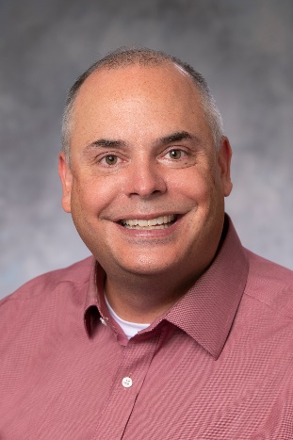
Dr. Nyman is the Associate Director of Behavioral Science for Family Medicine at Genesys, and is a faculty member of both the Behavioral Science Dept. and the Family Medicine Dept. at Genesys. His time is split between working with our Clinical Health Psychology postdoctoral fellowship program, our clinical psychology practicum program, and the Genesys Family Medicine residency program. Dr. Nyman's professional and research interests include integrating psychology services into medical settings and focusing on primary care prevention and wellness practices. Dr. Nyman has had recent opportunities to speak and publish on these topics, enjoys the opportunity to collaborate with psychology and medical colleagues on research and clinical quality improvement projects, and currently serves on the Ascension-Genesys patient experience committee.
Dr. Nyman is board certified in Clinical Health Psychology through the American Board of Professional Psychology (ABPP), and is a fully licensed psychologist in the State of Michigan, having earned his Ph.D. in counseling psychology from Purdue University in 2004, interning at the Utah State University Counseling and Student Health Centers in Logan, UT, and then returning to his home state of Michigan to complete a two-year postdoctoral fellowship in Clinical Health Psychology here at Genesys. Prior to his current position, Dr. Nyman spent four years at the Genesys-Hurley Cancer Institute in Flint, MI as their staff psychologist. Dr. Nyman is presently an Assistant Professor in the departments of Family Medicine and Psychiatry, Michigan State University College of Human Medicine.
Dr. Nyman lives locally with his wife, Heather, and their daughter, and enjoys spending time with family and friends. He is often found on the sidelines of his daughter's youth soccer games and enjoys traveling to Northern Michigan with family for summer getaways.

Rebecca Sewell, Psy.D.
Dr. Sewell is a faculty member within the Psychology and Medical Education departments at Ascension Genesys. She splits her time between managing our hospital-based psychology Consultation-Liaison service and working within the obstetrics-gynecology residency program. She also spends time teaching and supervising psychology fellows among our Clinical Health Psychology postdoctoral fellowship program.
Dr. Sewell is a fully licensed Clinical Psychologist in the state of Michigan. She earned her Psy.D. from Midwestern University in 2019. She completed her internship at the University of Texas Health Science Center in Tyler, TX. She then relocated to Michigan and completed her fellowship in Clinical Health Psychology at Ascension Genesys Hospital. Prior to her current position, she worked at Bon Secours Mercy Health in Toledo, OH as a behavioral health consultant. During that time, she worked in integrated primary care and weight management, which focused on bariatric pre-surgical evaluations. Her professional interests include chronic disease management, the integration of behavioral health into primary care, working with bariatric surgery patients pre- and post-surgery, and medical education.

Dr. Sewell lives locally with her husband, Matthew, and their lovable black lab, Addy.
She enjoys traveling, outdoor activities such as hiking and camping, and cooking. She completed her undergraduate studies at Virginia Tech and is a big fan of the Hokies football team.

Por Por Phunwutikorn, Ph.D.
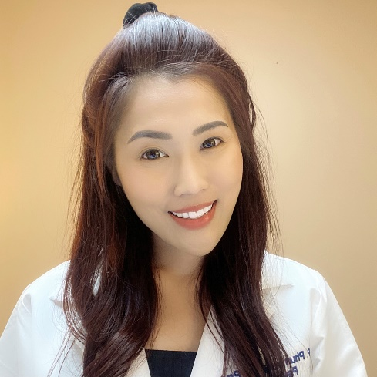
Dr. Phunwutikorn (pronounced Pan-wut-ti-gon) or Dr. Por Por is a licensed psychologist with Ascension Medical Group. She earned a Bachelor's Degree in Psychology, a Master’s Degree in Clinical Psychology, and obtained her license to practice as a clinical psychologist in Thailand prior to coming to the US. Dr. Por Por then earned her second master’s degree in Clinical Psychology from American School of Professional Psychology at Argosy University San Francisco Bay Area and her doctoral degree from California School of Professional Psychology at Alliant International University San Francisco. She completed her internship at Eastern Virginia Medical School and her postdoctoral fellowship in Clinical Health Psychology at Ascension Genesys. Her primary theoretical orientations include Narrative Therapy, Acceptance and Commitment Therapy, and Cognitive Behavioral Therapy.
Within the area of Clinical Health Psychology, Dr. Por Por has a special interest in working with bariatric patients. She currently practices as a psychologist at Ascension Genesys Bariatric Center. She provides psychological services, including pre-surgical psychological evaluations as well as pre- and post-surgical psychological interventions with the primary goal of providing comprehensive, patient-centered, and compassionate care. Dr. Por Por also serves as a supervisor of the Bariatric rotation of our Clinical Health Psychology postdoctoral fellowship program.
Outside of her role as a psychologist, Dr. Por Por enjoys spending time with her significant other and family. Dr. Por Por is passionate about cultures. She enjoys traveling and has taken almost 30 trips abroad.

Contact Us

For more information, please contact Alice Barillas, program manager at:
(810) 606-6954 or toll free 1-800-233-2863
email: alice.barillas@ascension.org

